**Don’t give skin cancer a chance !!!!!!**

**Book you appointment now test your skin from head to toes**

Mole Mapping is the best method for early detection of malignant melanoma (***worldwide)***

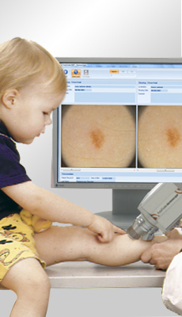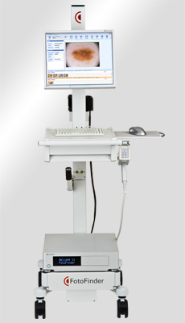

**For better diagnostic accuracy World wide**

FotoFinder ***dermoscope*** offers all in one, dermoscopic skin cancer screening and mole mapping, making it the imaging system of [choice](http://www.fotofinder-systems.com/) by thousands of dermatologists worldwide.  
The system automatically links digital dermoscopic images of moles to an overview image, making the identification and tracking of lesions easy. Through on-screen comparison of overview and microscopic mole images at follow-up visits, diagnostic accuracy can be significantly increased as even the slightest changes in mole structure are visualized and melanoma in situ and melanomas that do not [satisfy](http://www.fotofinder-systems.com/) the classical clinical features of melanoma are easier detected, examined and specified for surgery.

**Advantage of male mapping**

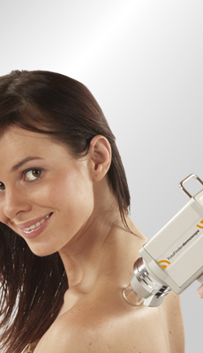

* Long term observation through mole

mapping provide the best prevention for

skin cancer

* Moles at risk and new moles are

detected at early stage

* Your doctors sees even slightest changes

in structures comparing your moles over

time, you can follow up the examinations

on screen

* Continuous skin checks are painless and

help to avoid unnecessary excisions of

benign moles

**UV*scan***

**Prevention is the Cure!**

The sun also has its side..

Melenoma skin cancer can arise from moles to that often have been inconspicuous over years or suddenly appear on healthy skin.

In recent years the number of melanoma cases has increased significantly risk factor is excessive exposure to sunlight. Therefore avoid intensive sunbathing and an eye on your skin!

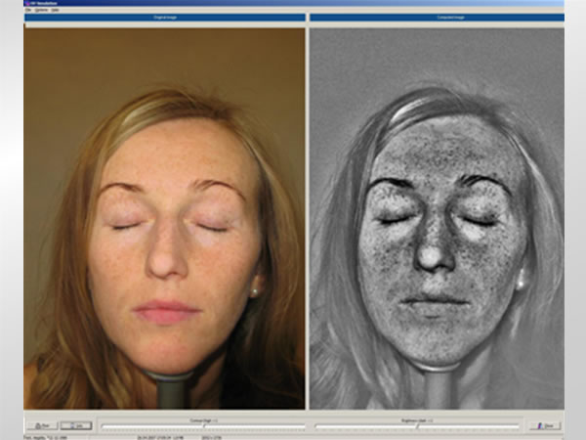

We can implement microscopic mole examinations with 20-70X magnification and auto focus for all zoom levels. The "screening" mode allows a fast examination of nevi without saving the images. Much more comfortable than using a hand dermatoscope!

|  |
| --- |
| Mole Mapping is the most advanced method for early diagnosis of skin cancer Worldwide |

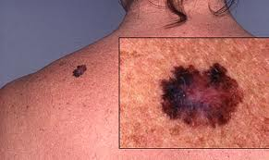

With the medical camera Dr Solomon takes microscopic photos of your moles(digital dermoscopy). Additionally , he takes overview images of your body to localize the moles and find them again at follow up visits. The mole images can be measured, analysed and stored in a digital database.

At a regular examinations, follow up images are taken and compared aside by side to detect even the slightest changes and possible skin cancer at an earl stage.